A/B Testing for Business Analytics

Jocelyn (Yuan) Li

Alteryx: Preparing the Data for Analysis

Analyzing Results in Alteryx

Selecting One Control unit For A treatment unit

Matching Stores Example

1. Randomized experiment

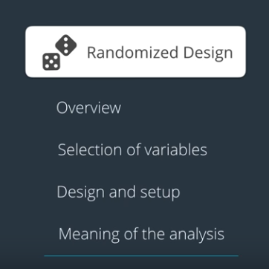

* What is the unit of diversion?
* What is the population of people we're targeting?
* What is the duration of the test?
* What is the size of our treatment and control groups?

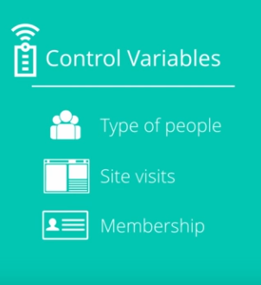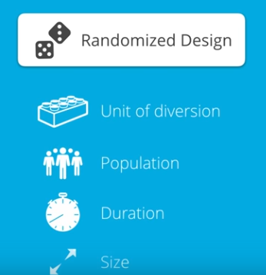

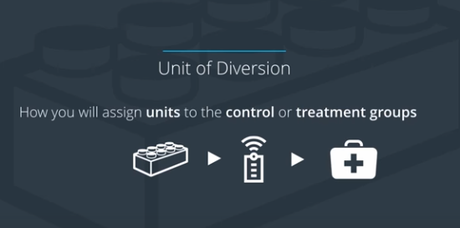

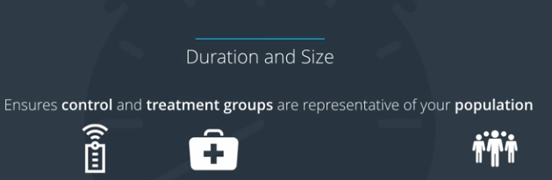

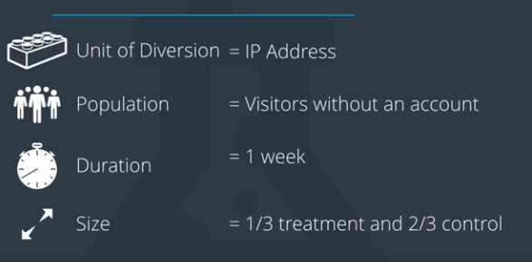

1. Data Preparation

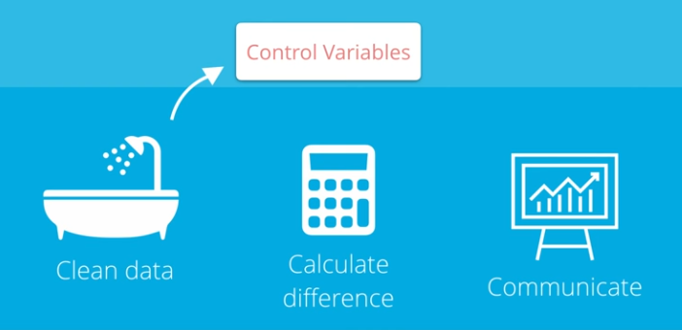

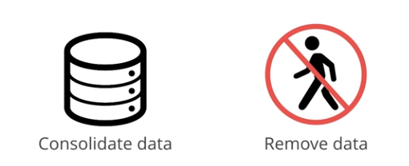

1. Analyzing the Results

Is there a statistically significance or not?

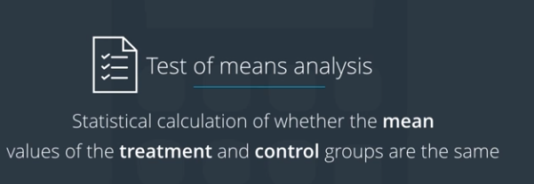

1. Matched Pair Design Treatment

